[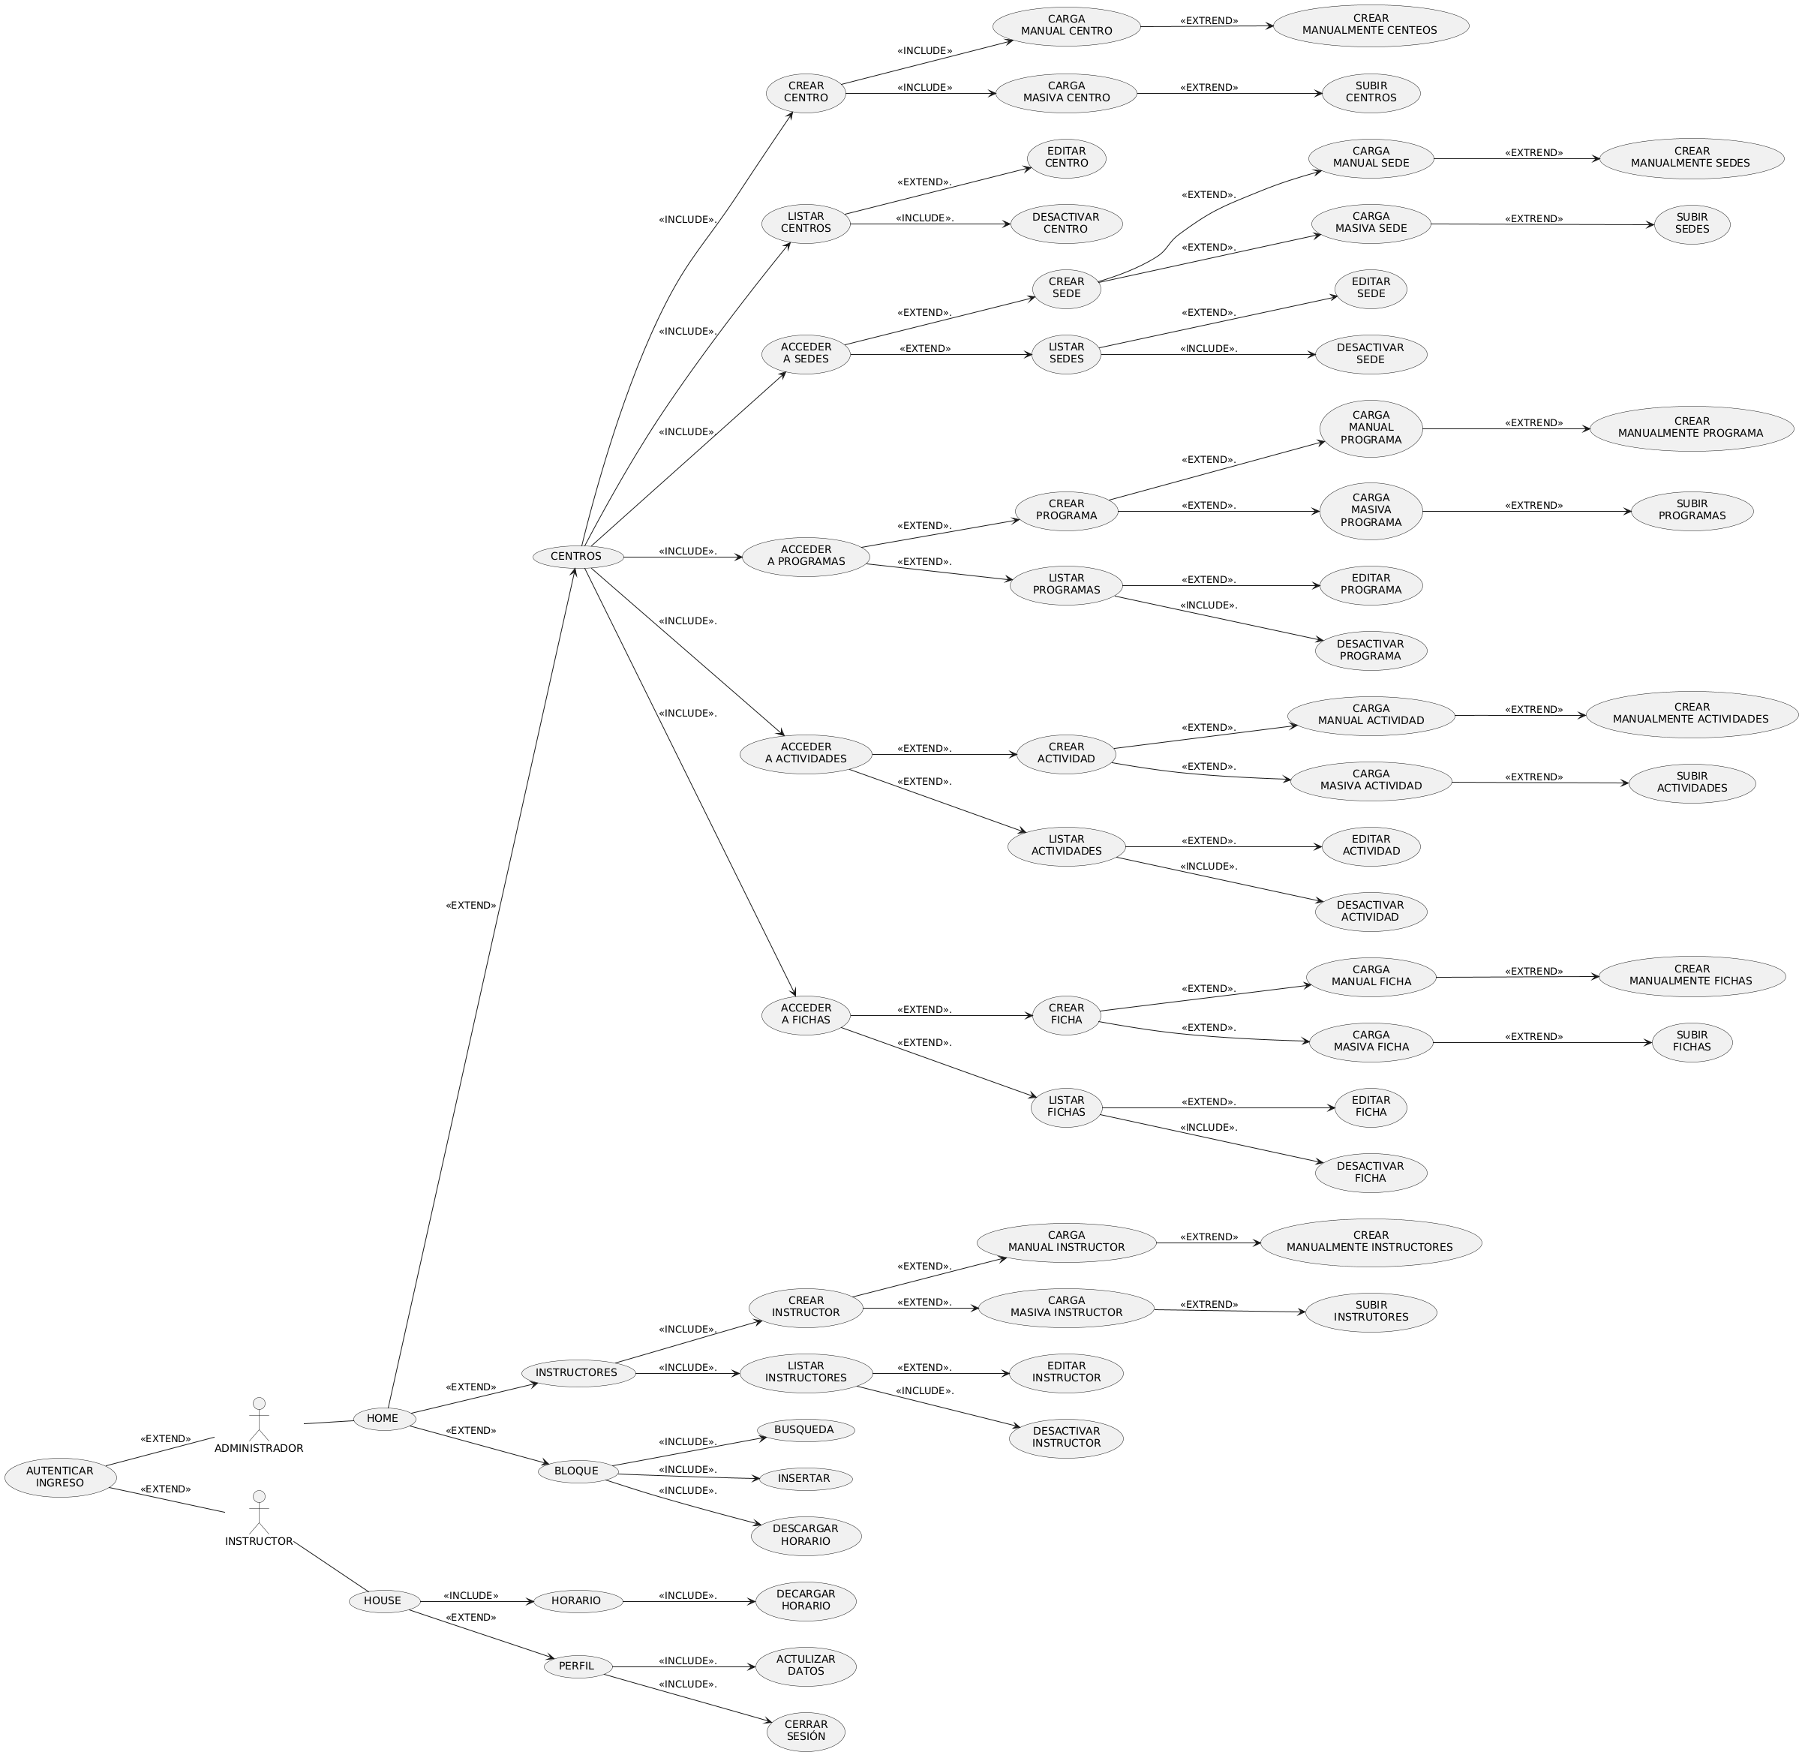](https://www.plantuml.com/plantuml/img/dPVDRjim3CVlVWeVaqFs045XGBNKH81ZTv8z34DlMxS6A5AWo9liaVPYa_LXKnAfVfmQYFnJ97-qIpy__hxMrvVwzVpdwLh_Ehy-_hoUNoxLdl6JxAKU5UE3sjUxNRqv3YUnhJPi6aK_ofQfXuli3qheORlRfOBzpOtuRXnvqrHEQM8qczP8rQ2tX5ds9i3KZeE9IldSTiFNIKJMQedhBb5YJiwTpOwoRxk9YwRvKYN6sR_Uc5eExE5oOlt4kXhHlI7JyXiZP5XahtOHdUbaBCBQnQ1hNvpojQFtk21wkfKcY3zCbKbVEeDdBKAddKdDLYEu7EDcXgvJ2YuqQqUJAOKWoOgrhU32EBDQcnzPMfaTCfvFagIWnRb633wai0t757b84gfDkemK10X0CHNLYu1XQT_wsCIcY2XI5k8DQGR5krZUg-6Wc2cmm7FrWKp3AKvfiUPiFocT4T1IuW8IT_0e4iy21UnBHrBqfRu5R57B4Qo9B0m2KJcXWWC1bUyQ2gkKd9KVS-W51sCvn_6kPkIn_wJMFfwabhY1d0rGMFc5aCOAuq47A3Smi4pwZz3Ef65Ag2QGGZWeaHXE2ZqgTx8z5byUtW4EY3t20JiJCXWVr5Wyg0Q9IWw2oxqy0p14u8_goAu4D6ih4MvG45XZzM7-4F6YYV566nrajHg83Gqu8DXYUSwELDlUqchg4X8bBB0CD8iMg3e36Y5lN-2GhihO9fUh0s6o0RGKmYRX6U9-FtUx-gJDRvx_Wu1E9fXGvjAYaxdTTjDSVXmKKpBVAeaFapNNFLoDuBd_l9dq_7tZ_jfBiPiYXtkXxcINV8i4bS_xhRHz3F_-6wTE_fZTEHlp5Htwja8fjvLf-UzldxZ-1m00)